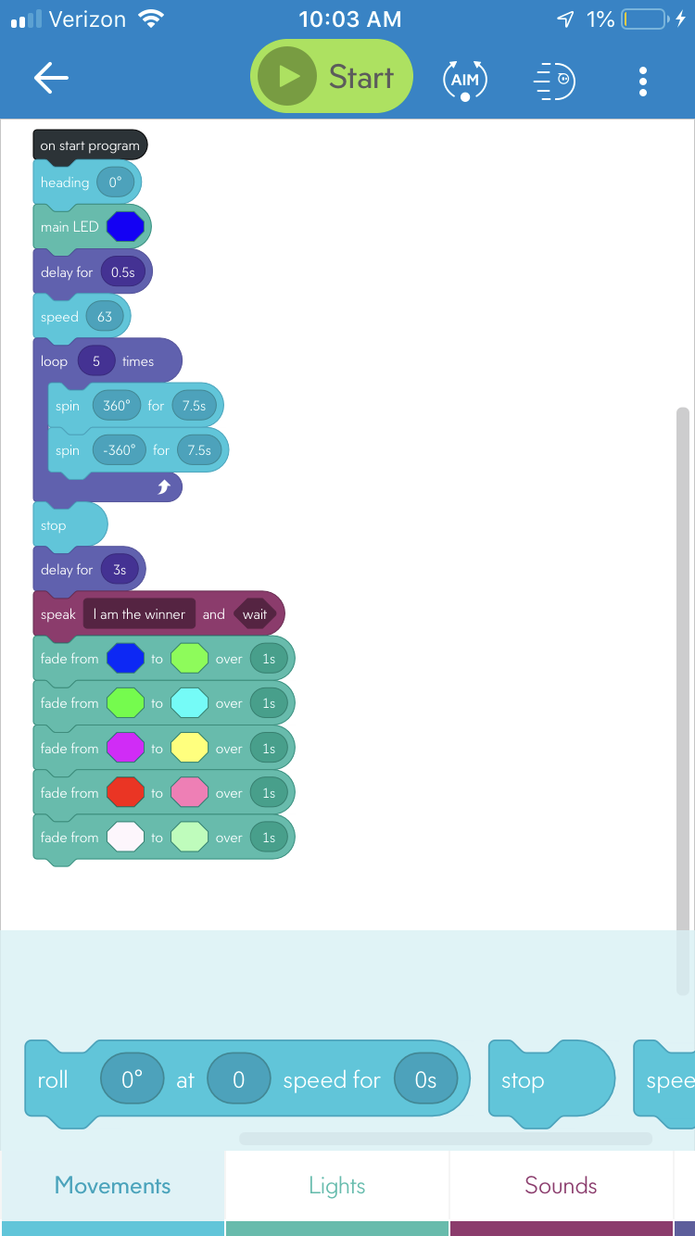

|  |  |  |  |  |
| --- | --- | --- | --- | --- |
| Reason For Test Case | Test Date | Expected Output | Observed Output | Pass/Fail |
| First test to see if it completes the requirement of the speed test loop infinite times to see if it continually goes in a figure 8 | 11/7 | Goes in figure 8 cleanly all the time will change the number of times to 5 at later time | Goes in a figure 8 sideways | Fail |
| Reaim the robot to the path instead of the person | 11/7 | Goes in figure 8 many times to stay on path will change numbers if off a bit | Now somewhat on path but offshooting a bit when on the massive turns needs to be tighter and need to reduce the loop to 5 times | Pass |
| Redo the loop to 5 times instead of infinite | 11/7 | Goes in figure 8 5 times | Went in figure 8 five times | Pass |
| Speed was at 150 overshooting way too far decrease to 70 and increase time turn from 6 to 8 | 11/7 | Cleanly goes in figure 8 | Figure 8 was overshot since it was too fast for the time amounted | Fail |
| Decrease speed to 63 and decrease the time to 7.5 | 11/7 | By decreasing the speed and the time it will turn at the right time and go in a figure 8 cleanly | It went in the figure 8 cleanly sometimes on the basis of not having a complete flat surface | Pass |